

Academic Corner

**Word Work**: Students will learn how to read the sound spelling cards to help with reading and writing.  There will be a brief review of a, m, s, and t to learn how to blend words.

**Reading:** Students will learn how to care for books, what reader’s workshop looks like and sounds like, and how to choose a just right book. .

**Writing:** Students will learn to write complete sentences about their likes and dislikes.

**Math:** Students will practice calendar/daily routines, count to 150 starting at any number, identify patterns on the 150 chart, compare numbers, determine missing numbers, explore time to the hour and half hour, identify coins, and recognize the value of each coin in pennies.

**Science/Social Studies:** Students will learn about why we need rules and procedures in different settings.

Upcoming Events

Sept 4 - Oct 10 - BOY testing window

Sept 6-Spirit Night 4-8 at Nothing But Noodles (Elizabeth)

Sept 6-Be There Dad Meetup at Dilworth Bar & Grille

Sept 12 - Early Release Day at 1:15

Sept 18 - Curriculum Night for K-2 @ 6:30

Sept 19 - NO SCHOOL - Teacher Workday

Sept 29 - MPTS Grounds Day

Important Information

-Please review the Parent Handbook on the MPTS website

-Please check your child’s folder nightly for important papers

-Complete and return all paperwork from Open House ASAP - Video Release form, volunteer forms, Green Emergency Sheet, Blue Health Card, Student Instructional Fees, and PTA Yearly Dues

-Be sure to check my website http://msschmidtke.weebly.com for general school and classroom information, important quick links, schedule etc. for the year.

Spelling Words List 1

On Level:  I, at, is, to, cat, hat, had, mad, nap, tap

Challenge:  I, at, is, to, flat, chat, glad, clad, snap, trap

**https://www.spellingcity.com/mschmidtke**

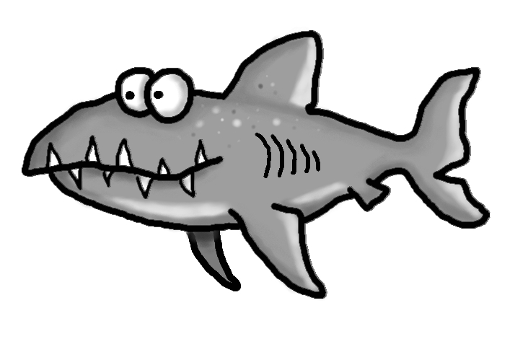

Schmidtke’s Sharks

Weekly News

