

Academic Corner

**Reading:** Students will learn focus on finding multiple settings in stories and begin working on retelling stories with a focus on the beginning of a story and problem/solution.

**Word Work:** This week’s spelling patterns are: -in, -ix, and -ick

**Writing:** Students will generate ideas and write about ways they help.

**Math:** Students will learn to count back to solve problems, use addition facts to help solve subtraction problems, draw pictures and write equations to solve problems, and make 10 in different ways.

**Science/Social Studies:** Students will learn about how to be a good citizen within the different communities they belong to.

Upcoming Events

Sept 29 - MPTS Grounds Day 9:00-1:00

Oct 3-Picture Day

Oct 3-Progress Reports go home

Oct 9-K-2 Curriculum Night

Oct 12-Reading Celebration Day

Oct 19-Riverbend Farms

Oct 20-Mother/Son Bowling

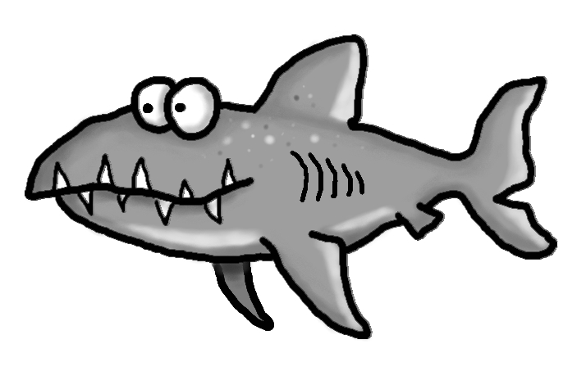s

Important Information

*Information regarding our first conferences will be sent home soon. Conferences will take place throughout the month of October. You can sign up for a time that works best with your schedule.

*K-2 Curriculum Night has been rescheduled for Tuesday, October 9th.

*I have one volunteer so far for our field trip to the farm. If you are interested in going be sure to let me know! This is a great trip to join!

*Please pay for our first field trip online. We are unable to accept personal checks this year-new CMS policy

*Please continue to check your child’s yellow folder daily

*You ***MUST*** sign up to be a CMS volunteer (each year) if you plan on participating in school activities or attending any field trips. This includes classroom activities and parties, so sign up now at [www.cmsvolunteers.com](http://www.cmsvolunteers.com)

Spelling Words List 3

**On Level:** in, the, a, look, win, pin, six, fix, kick, lick

**Challenge**: in, the, a, look, shin, grin, remix, helix, brick, thick

**https://www.spellingcity.com/mschmidtke**

Schmidtke’s Sharks

Weekly News

