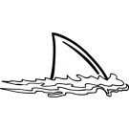

Academic Corner

**Reading:** Students will learn to use the illustrations in a book and the beginning letter sound to help them read the words in their books.

**Word Work:** This week’s spelling patterns are: -an, -am, and -ack.

**Writing:** Students will generate ideas and write about ways they help.

**Math:** Students will count on from a given number, use doubles to solve problems, use near doubles to solve problems, and use a tens frame to solve addition facts.

**Science/Social Studies:** Students will read about communities and the jobs people have within their communities.

Upcoming Events

Sept 12 - Early Release Day at 1:15

Sept 18 - Curriculum Night for K-2 @ 6:00

Sept 19 - NO SCHOOL - Teacher Workday

Sept 29 - MPTS Grounds Day 9:00-1:00

Important Information

*Early Release Day at 1:15 on Wednesday this week

*Please continue to check your child’s yellow folder daily

*You ***MUST*** sign up to be a CMS volunteer (each year) if you plan on participating in school activities or attending any field trips. This includes classroom activities and parties, so sign up now at [www.cmsvolunteers.com](http://www.cmsvolunteers.com)

Spelling Words List 2

**On Level:** my, you, and, come, van, ran, ham, jam, pack, sack

**Challenge:** my, you, and, come, span, plan, clam, gram, crack, stack

**https://www.spellingcity.com/mschmidtke**

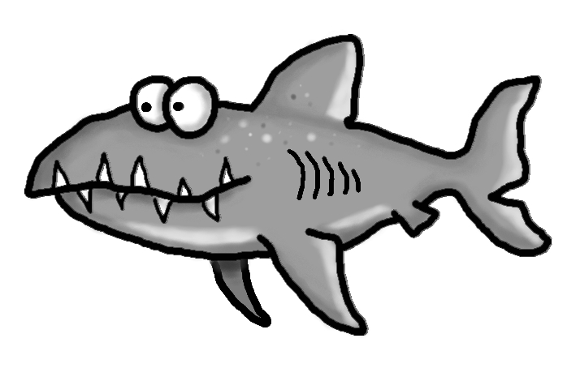

Schmidtke’s Sharks

Weekly News

