s

*PE on Thursday this week

**\*NO SCHOOL for students** on Wednesday, May 1st. ASEP will NOT be open on that day either.

\***Spring Carnival** is Friday, May 10th, along with all the usual fun activities, we will be holding a basket raffle to raise money for our PTA programs. We are asking students to contribute a new, unopened theme-related item to their grade-level basket. First Grade’s theme is Pampered Pet Basket Ideas Include: pet store gift card, greenies, treats, grooming brush, food bowls, lint brush, treat jar, toys  Due Date: Friday, May 3rd – Please send items to your child’s classroom

\***Permission slips** for our next ON CAMPUS field trip for the Raptor Center, is on Friday, May 17th.  We are not leaving the MPTS campus and therefore DO NOT need chaperones.

\***TRC State Reading Assessments** will being for first graders on April 22- May 17. Please make every effort to have your child at school during our testing window, as we must follow a schedule that is provided to us from administration.

*We are collecting gently used and new books for our Book Drive. Please send to school with child marked as “book drive”

*There will be a bus drill on Tuesday, April 30th. Please have your child wear pants or shorts with tennis shoes as they will be exiting out the back of the bus with assistance.

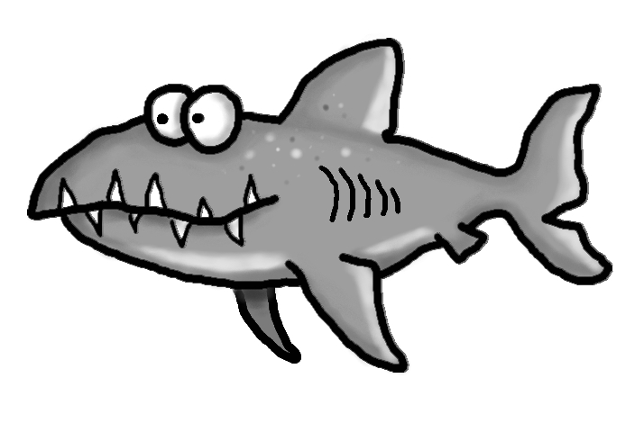

Upcoming Events

May 1-NO SCHOOL-ASEP will be closed as well

May 8-Progress Reports

May 10-Moments with Mom from 3:15-3:45 in classrooms

May 10-MPTS Spring Carnival 4:30-7:30

May 17-On Campus Field Trip

Academic Corner

**Reading:** Students will read a passage and answer questions about characters feelings.

**Writing:** Students will continue writing persuasive letters.

**Math:** Students will sort/graph coins and identify coin values equivalent to pennies.

**Shared Reading:**  Students will explore magnets and how they work

Weekly News

Schmidtke’s Sharks



Spelling Words List 28

**On Level**: some, this, were, has, ever, over, winter, liter, ruler, over

**Challenge**: some, this, has, ever, another, brother, fighter, writer, pattern, bitter

<https://www.spellingcity.com/mschmidtke/>