

Upcoming Events

**April 3**-9:30 am Q3 Awards Ceremony in the Levine Gym at Queens-you will be notified if your child is receiving an award

**April 11**-Egg Hunt at Queen’s College 1:00

**April 15-19**-Spring Break

Academic Corner

**Reading:** Students will ask and answer questions about fiction texts.

**Word Work:** This week’s spelling patterns have –ing and –ed in them.

**Writing:** Students will continue to write opinion pieces.

**Math:** Students willuse a variety addition and subtraction strategies to solve problems.

**Science/Social Studies:** Students will read and learn about the rock cycle.

*PE on Thursday this week

*please send in plastic eggs filled with treats numbered 1-22 on Wednesday, April 10th.

*Permission slips for our next ON CAMPUS field trip for the Raptor Center, is on Friday, May 17th.  We are not leaving the MPTS campus and therefore DO NOT need chaperones

\***Thank you SO much** to those of you who have helped contribute items on the sign up for our classroom. We still have a couple items needed. Please help if you can! Here is the link to the signup <https://www.signupgenius.com/go/30E0D4FAAA82CA3F58-supply>

**\*MAP TESTING DAYS: 4/2/19 Math, 4/5/19 Reading**

Schmidtke’s Sharks

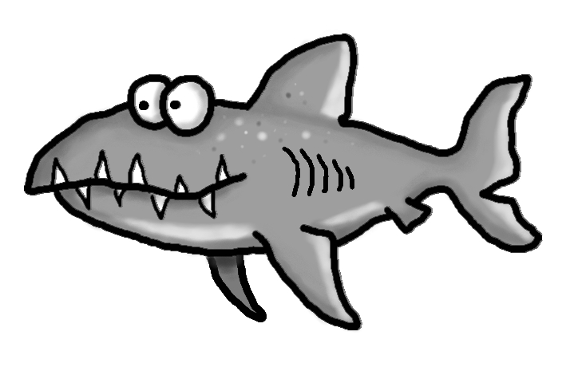

Spelling Words List 25

**On Level**: our, under, other, every, wishing, sleeping, barking, fixed, jumped, wanted

**Challenge**: our, under, other, every, sprinting, throwing, starting, shouted, locked, wished

<https://www.spellingcity.com/mschmidtke/>

Weekly News

