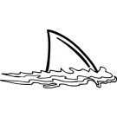

Upcoming Events

March 12 - Spring Pictures - only students who purchase will be photographed

March 12 - SLT - Poverty Simulation - 5:30 - 7:30 pm

March 13-Students can dress as their favorite Dr. Seuss character

March 13 - Early Release Day - 1:15

*Thank you, thank you, thank you for all of you who helped make Sfaff Appreciation Week so wonderful! I appreciate all who volunteered as well as helped get flowers and cards together for me.

*We will have PE on Thursday this week. Please have your student wear sneakers!

*Please be sure to return the permission slip and pay for our upcoming field trip online or send in your payment.

Academic Corner

**Reading:** Students will use illustrations to tell about characters, setting and events in a story.  Students will compare and contrast characters in a story.

**Word Work:** Students will learn and review spellings for long i. (ie, igh)

**Writing:**I can learn what an opinion is and write about my opinion on topics.

**Math:** Students will organize data into categories and collect information and organize it using a picture graph

**Shared Reading:**  Students will read and learn about the force of gravity and how it affects objects.

Schmidtke’s Sharks

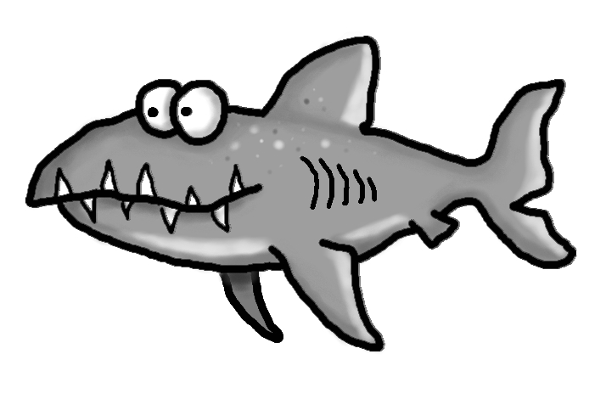

Spelling Words List 22

**On Level:** was, of, that, he, lies, tied, pie, high, right, night

**Challenge:** was, of, that, he, dried, tried, skies, flight, thigh, bright

<https://www.spellingcity.com/mschmidtke/>

Weekly News

