Academic Corner

**Reading:** Students will use a variety of strategies to discover the meaning of a word they don’t know in a nonfiction text by using text features, context clues, determining what word might make sense, using word parts, and using their knowledge of multiple meaning words. Finally, students will confirm their meaning by using a glossary.

**Word Work:** This week’s spelling patterns have silent –e at the end of the words.

**Writing:** Students will work on stories with beginning, middle, and ends.

**Math:** Students will use a number line to solve problems, solve problems with blocks and drawings, work on fluency of composing groups of ten, use tens to help solve problems, and solve addition problems using a variety of problems.

**Science/Social Studies:** Students will read about different types of maps and how we use them in our everyday lives.

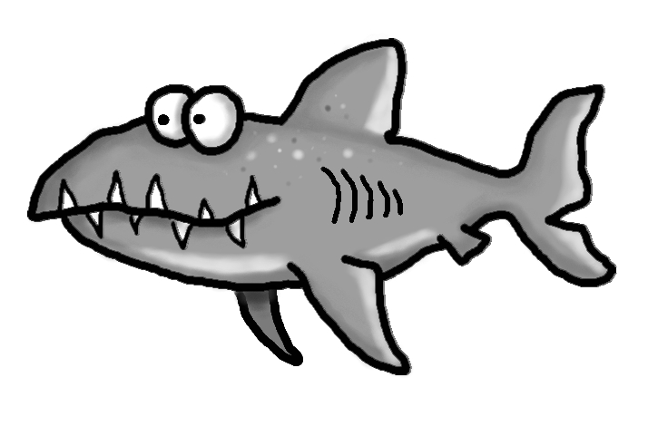

Upcoming Events

Feb   8 - Daughter Choice Dance

Feb 12 - Class Picture Day

Feb 14 - Valentine Celebration

Feb 22 - Leadership Day - 1:00 - 4:00

Schmidtke’s Sharks

Important Information

\***\*\*\*HELP\*\*\*\*\***We need pictures of your child being a leader at home or out in the community. Please send in photographs of your child being a leader so that I can hang them in the hallway on our “Leader” bulletin board. I would LOVE for each of my students to have their picture displayed! I know how involved this class is in the community by all of the awesome things they tell me they do during circle time. Let’s celebratethem!!!!

*Class Picture Day is Feb 12th-you can pay online at -https://www.classic-photo.com

*PE on Wednesday this week

Spelling Words List 17

On Level: know, after, live, just, nice, rice, lace, page, cage, huge

Challenge: know, after, live, just, spice, choice, grace, large, range, strange

**https://www.spellingcity.com/mschmidtke**

Weekly News

