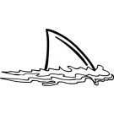

*Thank you all so much for the laminating pouches and Fruit Loop donations! I appreciate your help!

*We will have PE on Wednesday this week. Please have your student wear sneakers!

*Yearbook order forms went home last week ☺

*Remember it is Cafeteria Appreciation Week! I sent out a dojo message with a link to a signup to provide treats for our lady Pam Edwards. Thank you so much for your donations so far! She deserves it!

*We can’t wait to see you at leadership day. A special thank you for parents who sent in their RSVP cards!

Upcoming Events

Feb 18 - 100th Day Project is due

Feb 18-22 - Cafeteria Appreciation Week at MPTS

Feb 22 - Leadership Day - 1:00 - 4:00

Academic Corner

**Reading:** Students will distinguish between what is learned from words in a text as opposed to what is learned from the photographs.

**Word Work:** This week’s spelling patterns have –ea in them.

**Writing:** Students will continue to work on stories with beginning, middle, and ends.

**Math:** Students will use an open number line to solve subtraction problems, use addition to subtract tens, determine 1 more/less and 10 more/less using the 150 chart, and use mental math to subtract tens.

**Science/Social Studies:** Students will read and learn why we celebrate President’s Day and which presidents we honor on this special day.

Schmidtke’s Sharks

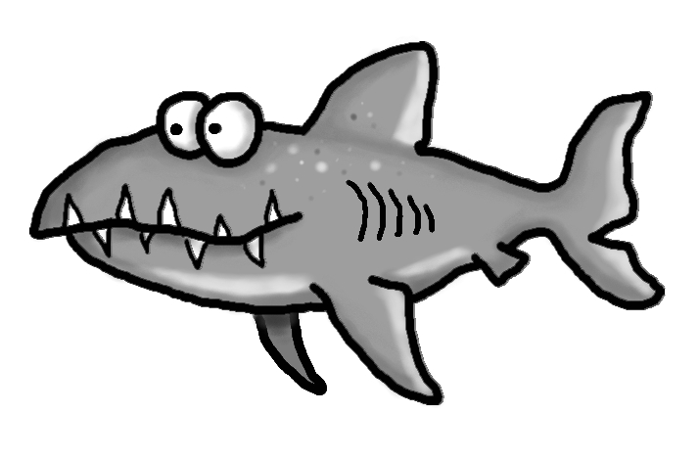

Spelling Words List 19

**On Level: now, these, about, my, eat, neat, real, team, mean, read**

**Challenge: now, these, about, my, treat, clean, beach, dream, reach, speak**

<https://www.spellingcity.com/mschmidtke/>

Weekly News

