Academic Corner

**Word Work:**

**Reading:** Students will describe the connection between two individuals, events, ideas, or two pieces of information in a text.

**Writing:** Students will write a story about a fun time.

**Math:** Students will understand the “=” sign means “has the same value as”,  find the missing number to make an equation true, use different strategies to solve addition word problems with 3 addends.

**Science/Social** **Studies:** Students will read about different Holiday traditions and different ways people celebrate

Important Information

*PE is on Thursday this week!

**\*First grade program is Thursday-Kids should wear Sunday best attire! No specific costumes will be worn. Please no holiday headbands-as students will not be standing on risers this year.**

Upcoming Events

Dec 4-Community Night at Libretto’s on Woodlawn Road, 4:30-8:30 pm

Dec 5- Early Release 1:15

Dec 5-Progress Reports come home

Dec 6-1st grade performance @ 6:15 in Belk Chapel

Dec 19 - Jan 2 - Winter Break - NO SCHOOL

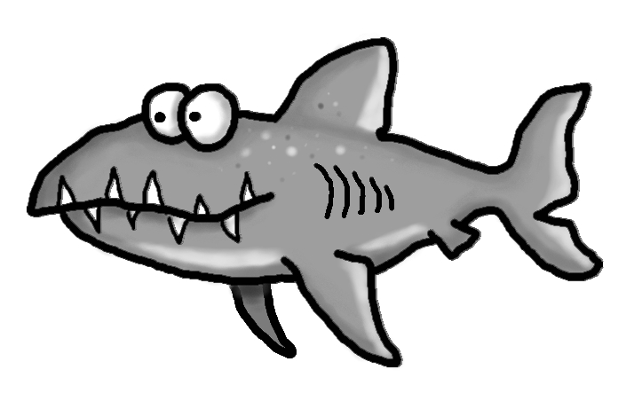s

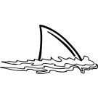



Spelling Words List 12

**On Level:** their, would, who, will, frog, drop, press, brag, tree, grass

**Challenge:** their, would, who, will, fresh, dream, prince, brick, track, grape

**https://www.spellingcity.com/mschmidtke**

Schmidtke’s Sharks

Weekly News