Upcoming Events

Dec 17-Polar Express Rotation-students can wear pajamas

Dec 18-Classroom Party 2:45-3:45-you ***MUST*** be a registered CMS volunteer to join us in the classroom for the party www.cmsvolunteers.com

Dec 19 - Jan 2 - Winter Break - NO SCHOOL

Important Information

*PE is on Friday this week!

* It’s a busy time of year and students are excited about the Holiday Season upon us. This is a great opportunity to speak to your child about being a leader. Discuss behavior choices and opportunities for leadership at this time of the year. Thank you!

*There will be NO Weekly News next week due to having only 2 days of school-I will send updates/information via Dojo

*Our MPTS Leadership Day will use the hashtag #leadingwithcare this year!

Academic Corner

**Reading:** Students will learn to identify text features in nonfiction texts and explain how they help them understand the text.

**Word Work:** This week’s spelling patterns are endings –nd, nt, sk, and -st.

**Writing:** I can write about a fantasy field trip.

**Math:** Students will read and write numbers 11-19 (beginning place value), count by 10s to 120, write a number to show how many are in a group, and solve problems using faster strategies.

**Science/Social Studies:** Students will read about different Holiday traditions that celebrate with light.

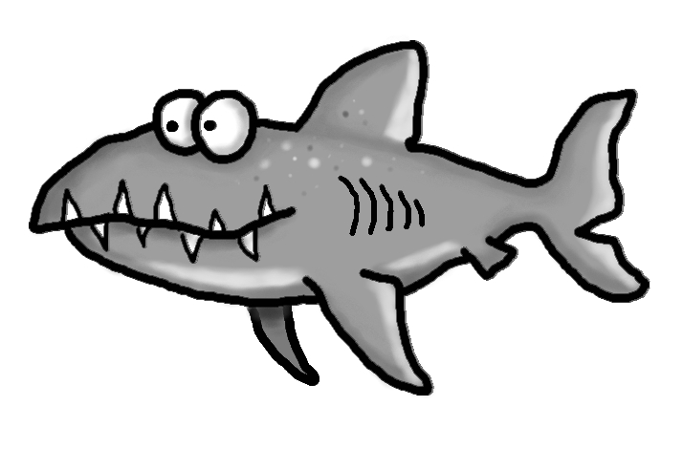s





Spelling Words List 13

**On Level**: out, two, if, into, hand, end, went, ask, fast, last

**Challenge**: out, two, if, into, stand, friend, sprint, whisk, trust, frost

**https://www.spellingcity.com/mschmidtke**

Schmidtke’s Sharks

Weekly News