Upcoming Events

Nov 8 - Gold Level Celebration

Nov 8 - Community Night - Pike’s Old Fashioned Soda Shop

Nov 9-Report Cards sent home

Nov 9 - Movie Night Under the Stars 6-9

Nov 12-Veterans Day - No School

Nov 13-16 Fall Bookfair - Black Box

Nov 16-Reading Celebration Day Makeup Date

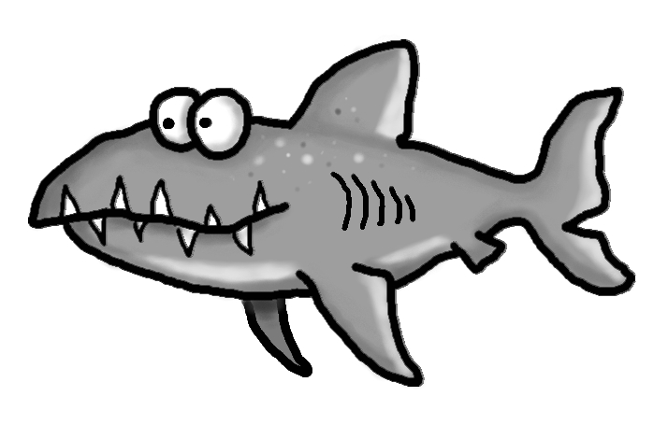s

Academic Corner

**Reading:** Students will practice identifying books as fiction and nonfiction and give reasons why.  They will also learn to ask and answer questions before, during, and after reading a nonfiction book.

**Word Work:** This week’s spelling patterns are endings –ff and -ss.

**Writing:** Students will write about activities they do with their families.

**Math:** Students will create fact families for 3 related numbers, use facts families to solve addition and subtraction problems, explain strategies used to solve subtraction problems, continue to solve addition and subtraction problems.

**Science/Social Studies:** Students will read and learn why we celebrate Veterans Day.

Important Information

*Check my website http://msschmidtke.weebly.com for general school and classroom information, important quick links, schedule etc. for the year.

* Please pay for our next field trip to see “The Best Christmas Pageant Ever” online using the link sent to you via Dojo and return the signed permission form ASAP.

*****Any students who are not permitted to ride the bus due to a bus suspension falling on the day of the trip will not be permitted to attend.*****

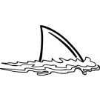



Spelling Words List 9

**On Level:** all, has, have, been, pass, miss, less, off, cuff, puff

**Challenge:** all, has, have, been, class, dress, stress, fluff, stuff, cliff

**https://www.spellingcity.com/mschmidtke**

Schmidtke’s Sharks

Weekly News