Academic Corner

**Reading:** Students will read nonfiction texts and identify the main idea and details that support them.

**Word Work:** This week’s spelling patterns are -l blends.

**Writing:** Students will tell and illustrate stories about something they observed.

**Math:** Students will understand the “=” sign means “has the same value as”, solve word problems with change unknown, and solve word problems by putting together or taking apart.

**Science/Social Studies:** Students will read about goods and services and learn how people pay for them.

Important Information

*Check my website http://msschmidtke.weebly.com for general school and classroom information, important quick links, schedule etc. for the year.

* Please pay for our next field trip to see “The Best Christmas Pageant Ever” online using the link sent to you via Dojo and return the signed permission form ASAP.

*****Any students who are not permitted to ride the bus due to a bus suspension falling on the day of the trip will not be permitted to attend.*****

*Make note that our 1st grade performance is around the corner! Please be sure to mark your calendars. Kids should wear Sunday best attire! No specific costumes will be worn.

Upcoming Events

Nov 21-23 No School - Thanksgiving Break

Nov 27- SLT Beaties Ford Library Room B

Nov 30- Field Trip to ImaginOn

Dec 5- Early Release 1:15

Dec 6- 1st grade performance @ 6:30 in Belk Chapel

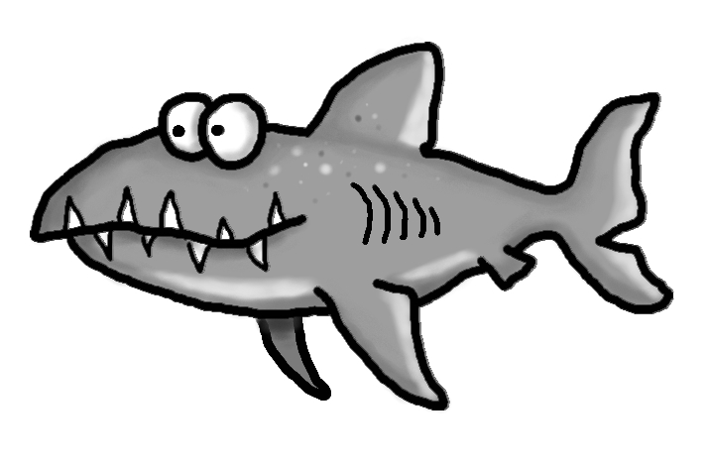s

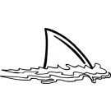



Spelling Words List 11

**On Level:** she, when, they, an, block, clap, flip, glad, play, slap

**Challenge:** she, when, they, an, blade, claw, flood, globe, plate, slow

**https://www.spellingcity.com/mschmidtke**

Schmidtke’s Sharks

Weekly News