Academic Corner

**Reading:** Students will practice identifying books as fiction and nonfiction and give reasons why.  They will also learn to ask and answer questions before, during, and after reading a nonfiction book.

**Word Work:** This week’s spelling patterns are l blends.

**Writing:** Students will write about activities they do with their families.

**Math:** Students will use reasoning to write and solve number stories within 20 to determine if they require addition or subtraction to solve and take an assessment

**Science/Social Studies:** Students will read and learn why we celebrate Thanksgiving.

Important Information

*Check my website http://msschmidtke.weebly.com for general school and classroom information, important quick links, schedule etc. for the year.

* Please pay for our next field trip to see “The Best Christmas Pageant Ever” online using the link sent to you via Dojo and return the signed permission form ASAP.

*****Any students who are not permitted to ride the bus due to a bus suspension falling on the day of the trip will not be permitted to attend.*****

*Make note that our 1st grade performance is around the corner! Please be sure to mark your calendars. Kids should wear Sunday best attire! No specific costumes will be worn.

Upcoming Events

Nov 21-23 No School - Thanksgiving Break

Nov 27- SLT Beaties Ford Library Room B

Nov 30- Field Trip to ImaginOn

Dec 5- Early Release 1:15

Dec 6- 1st grade performance @ 6:30 in Belk Chapel

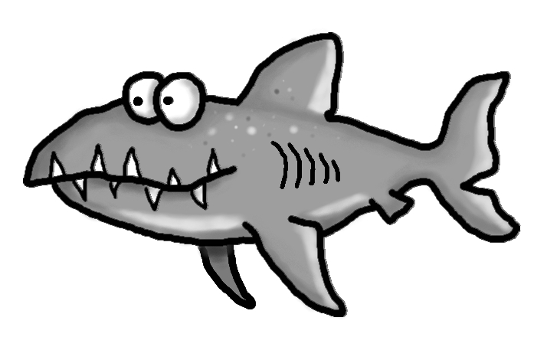s

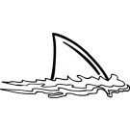



Spelling Words List 11

**On Level:** she, when, they, an, block, clap, flip, glad, play, slap

**Challenge:** she, when, they, an, blade, claw, flood, globe, plate, slow

**https://www.spellingcity.com/mschmidtke**

Schmidtke’s Sharks

Weekly News