Upcoming Events

Nov 13-16 Fall Book Fair - Black Box

Nov 13-Book Fair Family Night-4:30-7:30-Hadley Theatre

Nov 14-Fall Picture Retakes

Nov 16-Reading Celebration Day Makeup Date

Nov 21-23 No School - Thanksgiving Break

Important Information

*Check my website http://msschmidtke.weebly.com for general school and classroom information, important quick links, schedule etc. for the year.

* Please pay for our next field trip to see “The Best Christmas Pageant Ever” online using the link sent to you via Dojo and return the signed permission form ASAP.

*****Any students who are not permitted to ride the bus due to a bus suspension falling on the day of the trip will not be permitted to attend.*****

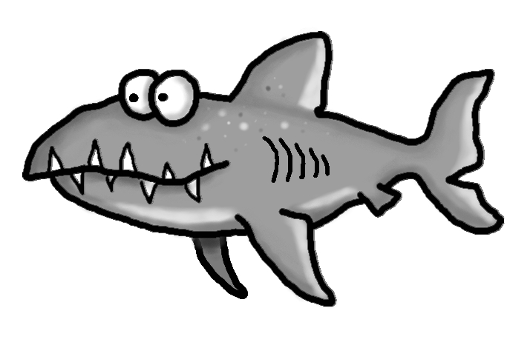

Academic Corner

**Reading:** Students will learn to ask and answer questions before, during, and after reading a nonfiction book.

**Word Work:** This week’s spelling patterns are s blends.

**Writing:** Students will tell stories before writing (BME), reread and add detail to their writing (and do their best to sound out words)

**Math:** Students will use reasoning to write and solve number stories within 20 to determine if they require addition or subtraction to solve and take an assessment.

**Science/Social Studies:** Students will read and learn about what life was like for Pilgrim children.

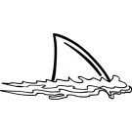



Spelling Words List 10

**On Level:** they, an, she, when, sniff, small, spot, skip, slime, sled

**Challenge:** they, an, she, when, snack, smash, spoil, skirt, steal, stick

**https://www.spellingcity.com/mschmidtke**

Schmidtke’s Sharks

Weekly News