Important Information

*Don’t forget to sign up for a conference time. The link was sent to you in a Dojo message. Just click on it to sign up for a time.

* PE is on Tuesday this week-please wear tennis shoes

*K-2 Curriculum Night has been rescheduled for Tuesday, October 9-6:30 PTA Meeting

*On Reading Celebration Day, students are encouraged to dress as their favorite storybook character-join us for the picnic on the field at 11:00

*Check my website http://msschmidtke.weebly.com for general school and classroom information, important quick links, schedule etc. for the year.

Academic Corner

**Reading:** Students will retell the end of a story and include the solution to the problem and the way the character changed.

**Word Work:** This week’s spelling patterns are –en, -et, and -ell.

**Writing:** Students can visualize and write about what they like to do with their friends.

**Math:** Students will count on using a number line, utilize an open number line to count of faster, master facts for doubles, use doubles facts to solve near doubles, visualize a story problem to determine which operation is needed to solve.

**Science/Social Studies:** Students will read and learn more facts about the moon.

Upcoming Events

Oct 9-K-2 Curriculum Night-PTA Meeting begins at 6:30

Oct 12-Reading Celebration Day-Picnic at 11:00 on the field

October 15 - Community Night at Chipotle in Cotswold

Oct 19-Riverbend Farms

Oct 20-Mother/Son Bowling

Oct 31-Teacher Work Day





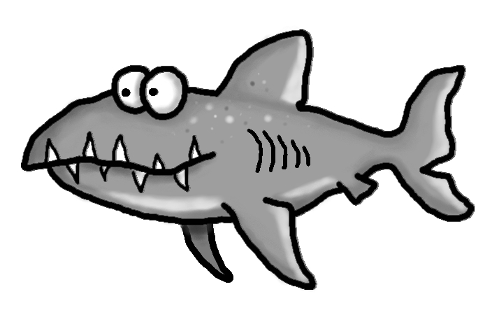s

Spelling Words List 5

**On Level:** go, it, we, up, pen, hen, jet, get, tell, yell

**Challenge:** go, it, we, up, wren, glen, forget, fret, swell, shell

**https://www.spellingcity.com/mschmidtke**

Schmidtke’s Sharks

Weekly News