Academic Corner

**Reading:** Students will learn the difference between fiction and nonfiction texts and be able to explain why a book is fiction or nonfiction.

**Word Work:** This week’s spelling patterns are –all and –ell.

**Writing:** Students will write about their families.

**Math:** Students will have an assessment on Topic 3 (solving word problems) and practice subtracting using the number line and counting back to find the difference.

**Science/Social Studies:** Students will read and learn why we have day and night.

Upcoming Events

Oct-30-Quarter 1 Ends

Oct-30-Fall Celebration-

Oct 31-Teacher Work Day - **No School**-conferences scheduled

Nov 2-Movie Night Under the Stars-6:00-9:00

Nov 8 - Community Night - Pike’s Old Fashioned Soda Shop

Nov 9-Report Cards sent home

Nov 12-Veterans Day - No School

Nov 13-16 Fall Bookfair - Black Box

Nov 16-Reading Celebration Day Makeup Date

Important Information

* PE is on Thursday this week!

*Check my website http://msschmidtke.weebly.com for general school and classroom information, important quick links, schedule etc. for the year.

*NO SCHOOL on Wednesday-Teacher Work Day. Please make sure to arrive on time for your scheduled conference, as I have conferences scheduled back to back that day.

*Please pay for, sign and return the new field trip permission form to see the play “The Best Christmas Pageant Ever”.

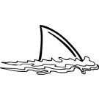



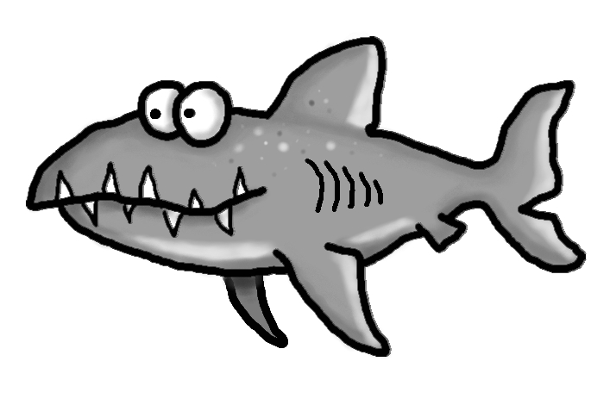s

Spelling Words List 8

**On Level:** or, him, were, her, ball, wall, tall, yell, bell, sell

**Challenge:** or, him, were, her, small, recall, stall, shell, dwell, smell

**https://www.spellingcity.com/mschmidtke**

Schmidtke’s Sharks

Weekly News