Academic Corner

**Reading:** Students will continue to look for central messages/lessons characters learn in stories.

**Word Work:** This week’s spelling words are a short vowel review.

**Writing:** Students can write about special places.

**Math:** Students will visualize, retell, and come up with a plan to solve story/word problems.

**Science/Social Studies:** Students will read information and details about the sun.

Upcoming Events

Oct-30-Quarter 1 Ends

Oct-30-Fall Celebration

Oct 31-Teacher Work Day

Nov 2-Movie Night Under the Stars-6:00-9:00

Nov 7-Gold Level Celebration

Nov 16-Reading Celebration Day Makeup Date

Important Information

*Please pay for and sign and return the new field trip permission form to see the play The Best Christmas Pageant Ever. I encourage you to please, pay online.

*Don’t forget to sign up for a conference time. The link was sent to you in a Dojo message. Just click on it to sign up for a time

* PE is on Thursday this week, but we will be on our field trip

*Reading Celebration Day will be rescheduled on Friday, Nov 16

*Check my website http://msschmidtke.weebly.com for general school and classroom information, important quick links, schedule etc. for the year.

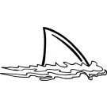



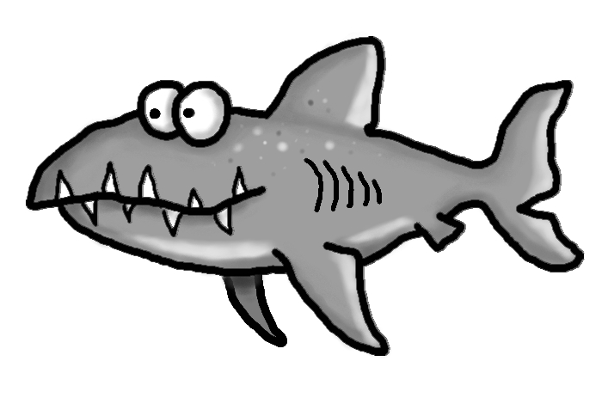s

Spelling Words List 7

**On Level:** we, you, from, but, sum, luck, bag, dog, sip, web

**Challenge:** we, you, from, but, plum, truck, mask, slob, chin, vest

**https://www.spellingcity.com/mschmidtke**

Schmidtke’s Sharks

Weekly News