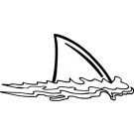

Upcoming Events

Oct 3-Picture Day

Oct 3-Progress Reports go home

Oct 9-K-2 Curriculum Night

Oct 12-Reading Celebration Day-11:00 Picnic Lunch on the Field

Oct 19-Riverbend Farms

Oct 20-Mother/Son Bowling

Oct 31-Teacher Work Day

Important Information

*Information regarding our first conferences will be sent home this week. Conferences will take place throughout the month of October. You can sign up for a time that works best with your schedule.

*K-2 Curriculum Night has been rescheduled for Tuesday, October 9th from 6:30-8:00.

*Please pay for our first field trip online. We are unable to accept personal checks this year-new CMS policy

*On Reading Celebration Day, students are encouraged to dress as their favorite storybook character.

Academic Corner

**Reading:** Students will learn to identify the problem and solution in a story and retell the middle of a story.

**Word Work:** This week’s spelling patterns are –op, -ot, -ock.

**Writing:** Students will write about what they want to be when they grow up.

**Math:** Students will learn how to use the number line and part part mat to solve addition and subtraction equations.

**Science/Social Studies:** Students will learn that the moon’s shape has a pattern that it follows.  Students will keep a moon journal for the month at home.

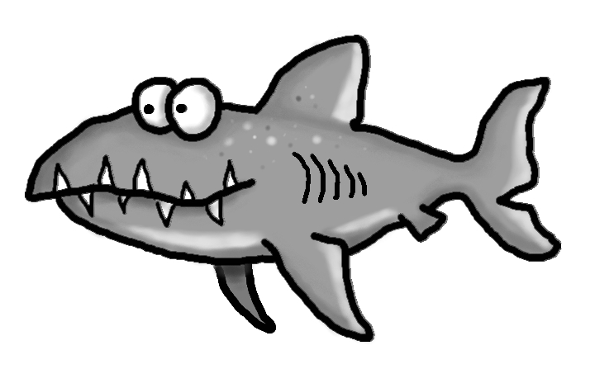s

Spelling Words List 4

**On Level:** here, said, like, me, dot, not, pop, mop, lock, sock

**Challenge:** here, said, like, me, spot, plot, chop, drop, shock, knock

**https://www.spellingcity.com/mschmidtke**

Schmidtke’s Sharks

Weekly News

