Spelling Words List 14

**On Level:** can, them, so, may, long, sang, ring, bank, wink, sink

**Challenge**: can, them, so, may, thing, bring, crying, think, drink, blank

**https://www.spellingcity.com/mschmidtke**

Academic Corner

**Reading:** Students will identify and explain how nonfiction text features help them understand their text and use the text features to answer questions about a text.

**Word Work:** This week’s spelling patterns are endings –ng and -nk.

**Writing:** Students will write stories about wishes.

**Math:** Students will use drawings of 10s and 1s to solve problems and find 1 more/1 less and 10 more/10 less than a number using the 150 chart.

**Science/Social Studies:** Students will read and learn about the science of sound.

Upcoming Events

Jan 3- MClass Testing begins

Jan 8- Community Night - Bad Daddy’s East Blvd.

Jan 9- Early Release 1:15

Jan 17-K-5 Curriculum Night 6:30 - 8:00 pm

Jan 21- Holiday

Jan 22- Teacher Work Day

Jan 23- Quarter 2 Award Ceremony at 9:30-Levine

Weekly News

Schmidtke’s Sharks

Important Information

* Our MCLASS testing has begun in first grade. Please continue to have your child read EACH night and don’t forget to practice nonsense words. January nonsense words are in the back pocket of your child’s yellow folder.

\***Early Release Day on Wednesday at 1:15**

\***PE** on Monday this week-PE-please wear tennis shoes

* Jan 14-New Year’s Resolution Project Due

*Our MPTS Leadership Day will use the hashtag #leadingwithcare this year!

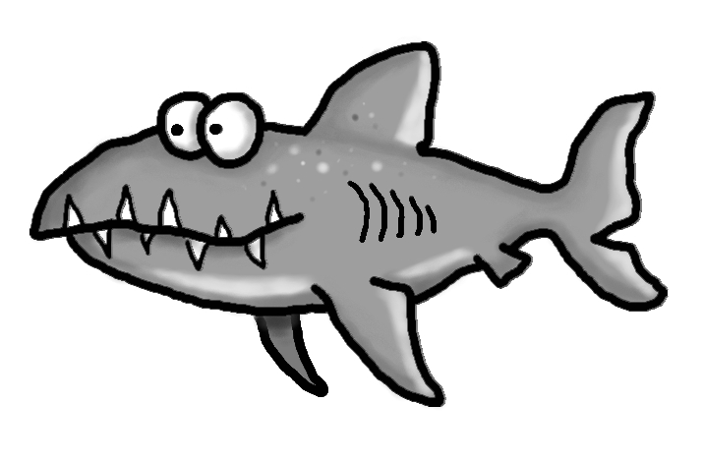s

