Academic Corner

**Reading:** Students will learn to identify who is telling the story including when it is a narrator.

**Word Work: No Spelling Words this Week**

**Writing:** Students can hear, discuss, and write stories about silly animals.

**Math:** Students will compare and write two digit numbers using the greater than, less than, or equal sign and communicate strategies used to compare numbers.

**Science/Social Studies:** Students will read different passages and determine who is telling the story.

Upcoming Events

Jan 23- Quarter 2 Award Ceremony at 9:30-Levine

Jan 25-Spirit Wear Day-Wear your MPTS Gear

Important Information

\***PE** on Wednesday this week-PE-please wear tennis shoes

*Please RSVP for MPTS Leadership Day by using the blue sheet of paper that was stapled to the invitation that your child brought home. We need to get an approximate number of attendees in order for planning purposes.

*If you have any photographs of your child being a leader out in the community, please send a copy in your child’s yellow folder. We want to fill our “LEADER” board with all the amazing things our students do as leaders in and out of MPTS. #leadingwithcare

Spelling Words List

**No spelling this week**

**https://www.spellingcity.com/mschmidtke**

Weekly News

Schmidtke’s Sharks

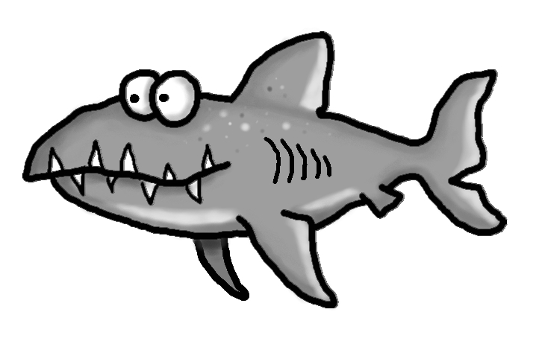s



