Academic Corner

**Reading:** Students will use nonfiction texts to decide what information they learn from the photograph and what information they learn from the words of the text.

**Word Work:** This week’s spelling patterns are i-e and o-e.

**Writing:** Students can hear, discuss, and write stories about silly animals.

**Math:** Students will use place value blocks to compare two digit numbers, compare numbers using the greater than/less than symbol, and use the hundreds board to determine 1 more/1 less and 10 more/10 less.

**Science/Social Studies:** Students will read and learn about Martin Luther King Jr. and why he is an important leader.

Upcoming Events

Jan 14-New Year’s Resolution Project Due

Jan 17-K-5 Curriculum Night 6:30 - 8:00 pm

Jan 18-End of Quarter 2

Jan 21- Holiday

Jan 22- Teacher Work Day

Jan 23- Quarter 2 Award Ceremony at 9:30-Levine

Important Information

*New Year’s Resolution project due on Monday.

*State testing will continue this week in first grade.

\***PE** on Monday this week-PE-please wear tennis shoes

*Our MPTS Leadership Day will use the hashtag #leadingwithcare this year!

Spelling Words List 14

**On Level:** up, new, first, what, like, ride, time, home, rode, hope

**Challenge**: up, new, first, what, slice, while, strike, chose, alone, stone

**https://www.spellingcity.com/mschmidtke**

Weekly News

Schmidtke’s Sharks

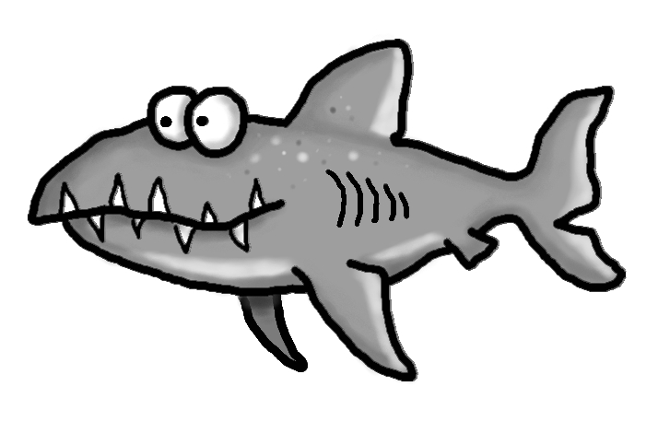s



