Academic Corner

**Reading:** Students will compare and contrast nonfiction passages on the same topic

**Word Work:** This week’s spelling patterns have –oo in them.

**Writing:** Students will research animals and their habitats.

**Math:** Students will identify 2D and 3D shapes by their defining attributes.

**Science/Social Studies:** Students will read and learn about plants and animals that live in the rainforest habitat.

Upcoming Events

May 8-Progress Reports Go Home

May 10-Moments with Mom from 3:15-3:45 in classrooms

May 10-MPTS Spring Carnival 4:30-7:30

May 17-On Campus Field Trip

May22- Animal parade 9:30am

Spelling Words List 29

**On Level:** your, use, get, make, soon, boot, room, food, zoom, moo

**Challenge:** your, use, get, make, tooth, broom, scooted, cooling, choose, spoon

**https://www.spellingcity.com/mschmidtke**

Important Information

\***PE** on Friday this week- please wear tennis shoes

*Spring Carnival is Friday, May 10th from 4:30-7:30. I hope to see you there!!!

*We are collecting gently used and new books for our Book Drive. Please send to school with child marked as “book drive”

*MPTS is in need of proctors for the EOGs. Please use the link sent via Dojo if you are able to serve as a volunteer. Thank you for your help with this!

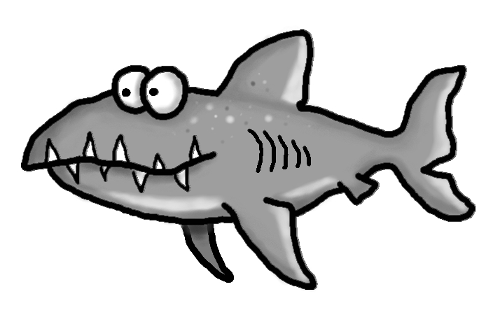

Weekly News

Schmidtke’s Sharks



