Academic Corner

**Reading:** Students will compare and contrast nonfiction passages on the same topic and find evidence in the text to compare the texts.

**Writing:** Students will finish their research books about their animal and celebrate by participating in the Animal Parade on Wednesday morning.

**Math:** Students will determine if shapes are divided into equal parts and divide shapes into 2 and 4 equal parts.

**Science/Social Studies:** Students will be reading and learning about why we celebrate Memorial Day and who we honor on that day.

Upcoming Events

**May 22-First Grade Animal Parade at 9:30**

**May 31- Balloons with dad at 2:00-3:00**

May 31- All books must be returned to the Media Center (No more book check out!)

No More Spelling!

*If you are interested in reviewing spelling with your student, feel free to use the lists on spelling city!

**https://www.spellingcity.com/mschmidtke**

Important Information

\***PE** on Friday this week- please wear tennis shoes

\****NO SCHOOL*** next Monday, May 27 for Memorial Day

*We are collecting gently used and new books for our Book Drive. Please send to school with child marked as “book drive”

*MPTS is in need of proctors for the EOGs. Please use the link sent via Dojo if you are able to serve as a volunteer. Thank you for your help with this!

*Please go over behavior expectations once again with your child. This is an exciting time of year for students, however learning will continue until the last week of school.

*Thank you to those of you who have signed up for end of the year supplies on the Sign Up Genius! Your donations are appreciated!

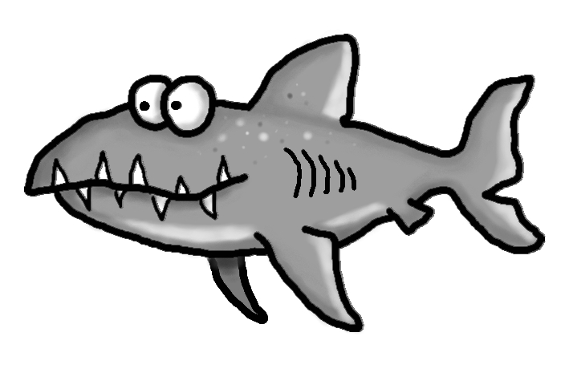

Weekly News

Schmidtke’s Sharks

