Academic Corner

**Reading:** Students will compare and contrast nonfiction passages on the same topic.

**Word Work:** This week’s spelling patterns have –ou and -ow in them.

**Writing:** Students will continue to write their research books about their animal.

**Math:** Students will identify attributes of a 3D shape, construct new shapes using 3D shapes, and sort 2D and 3D shapes.

**Science/Social Studies:** Students will read and learn more about the pond habitat.

Upcoming Events

May 17-On Campus Field Trip

May 22-First Grade Animal Parade at 9:30

May 31- Balloons with dad at 2:00-3:00

May 31- All books must be returned to the Media Center (No more book check out!)

Spelling Words List 30

**On Level:** more, these, each, part, count, house, loud, now, down, town

**Challenge:**  more, these, each, part, cloud, shout, ground, clown, brown, frown

**https://www.spellingcity.com/mschmidtke**

Important Information

\***PE** on Friday this week- please wear tennis shoes

*We are collecting gently used and new books for our Book Drive. Please send to school with child marked as “book drive”

*MPTS is in need of proctors for the EOGs. Please use the link sent via Dojo if you are able to serve as a volunteer. Thank you for your help with this!

*Please go over behavior expectations once again with your child. This is an exciting time of year for students, however learning will continue until the last week of school.

*Thank you to those of you who have signed up for end of the year supplies on the Sign Up Genius already. We still have a few things we need, if you would like to sign up please use the link sent last week via Dojo.

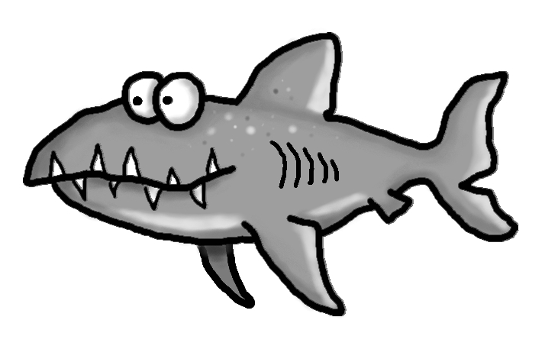

Weekly News

Schmidtke’s Sharks

