Upcoming Events

April 11-Egg Hunt at Queen’s College 1:00

**Spirit Week Calendar:**

Monday-College or Team Day

Tuesday-Dress-Up/Professional Day

Wednesday-Wacky Tacky Wednesday

Thursday-Grade Level Color Wars-First grade Wears Yellow

Friday-MPTS Red/Blue

April 15-19-Spring Break

April 22- Reading 3D testing window opens

Academic Corner

**Reading:** Students will continue to read fiction text, and answer questions about the central message.

**Writing:** Students will continue to write opinion papers.

**Math:**Students will learn to tell time to the hour and half hour.

**Shared Reading:**  Students will read and learn about the 3 different types of rocks and how to identify them.

Spelling Words List 25

**On Level:** people, many, down, look, car, farm, yard, or, born, fort

**Challenge:** people, many, down, shark, parked, barking, sports, thorn, storming

**https://www.spellingcity.com/mschmidtke**

Important Information

\***PE** on Thursday this week- please wear tennis shoes

*please send in plastic eggs filled with treats numbered 1-22 on Wednesday, April 10th.  On the day, please send in a basket/bag for your child to put their collected eggs in.

*Permission slips for our next ON CAMPUS field trip for the Raptor Center, is on Friday, May 17th.  We are not leaving the MPTS campus and therefore DO NOT need chaperones.

*TRC State Reading Assessments will being for first graders on April 22nd  and run through May 17th. Please make every effort to have your child at school during our testing window, as we must follow a schedule that is provided to us from administration.

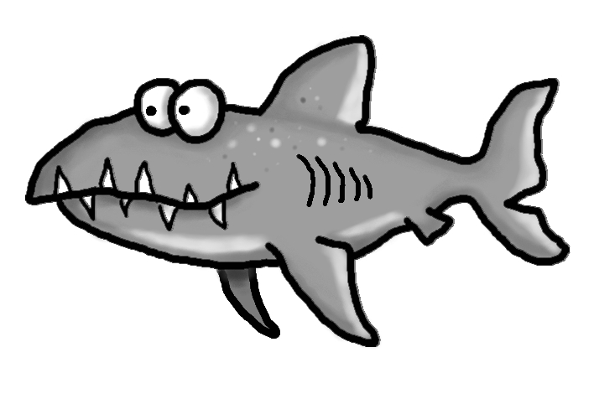

Weekly News

Schmidtke’s Sharks



